**FIS- Fixed income Documentation:**

Create Security Maintenance: For Bill

There are two types of Security.

1. Bill (Time period = less than 1 year)
2. Bond (Greater than 1 year)

Step 01: Go to Treasury Module then -> Fixed income -> Front Office -> security maintenance.

Step 02: Fill up this form.

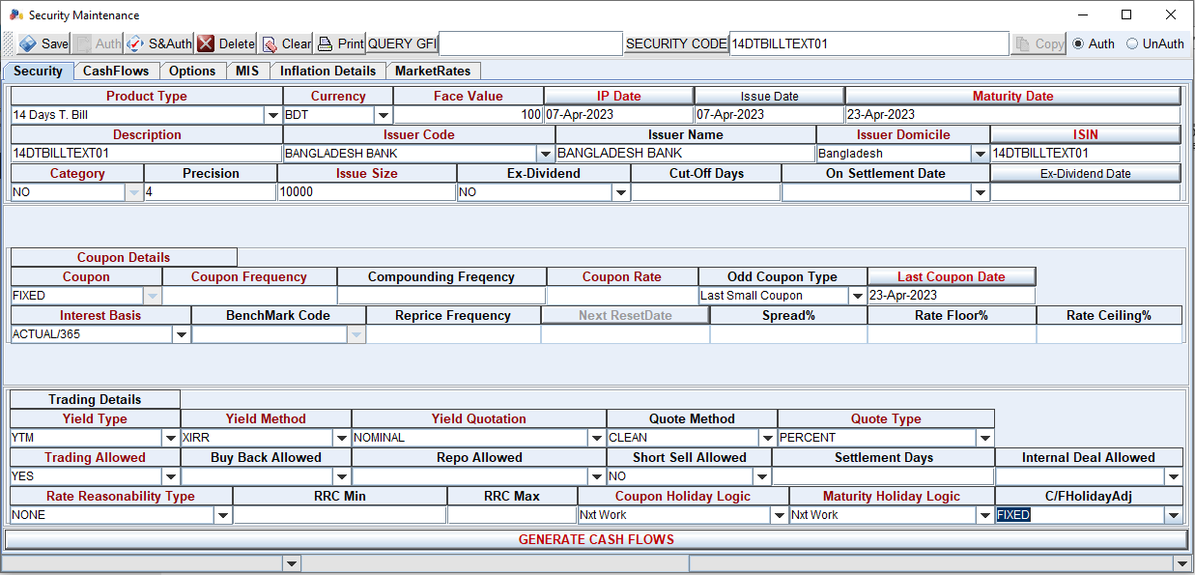

Security:

Face value: 100 fixed

IP Date: This is effective date (It can be previous date)

Issue date: when it’s created (we usually used IP date= issue date)

ISIN: It must be unique (It’s used by respective bank)

Coupon Details: Coupon means Interest, for bill product there is no interest issue.

Last coupon date: It’s maturity date.

Interest Basis: select Actual/364 for bill product

Step 03: After Fill up Security form then click MIS

Reserve Eligibility: SLR

Then Click + button, then auto add a column.

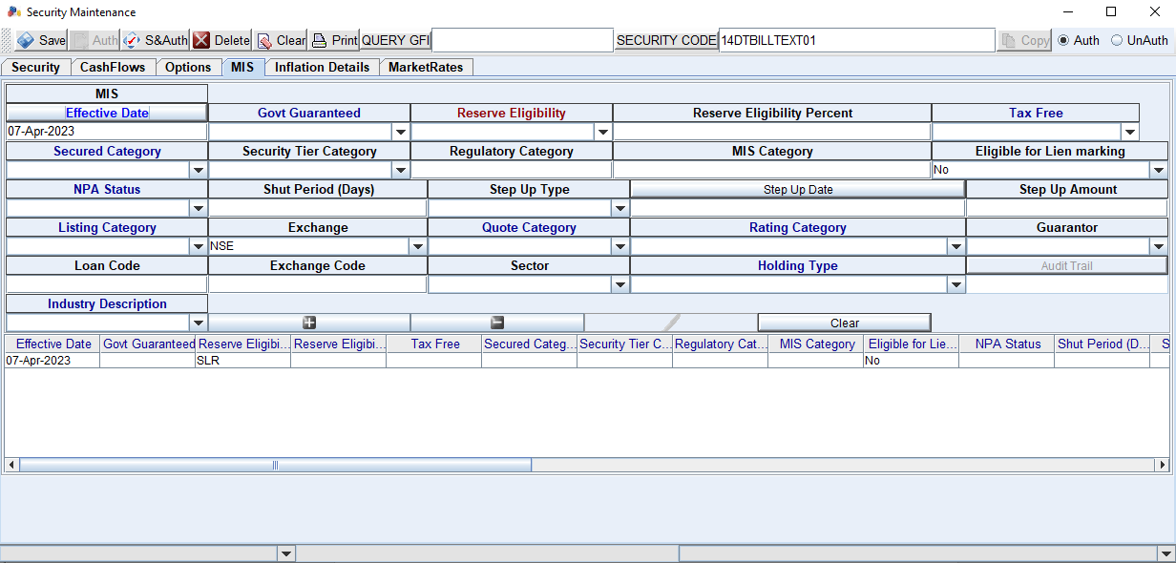

Step 04: Back to security then click Generate Cash Flow

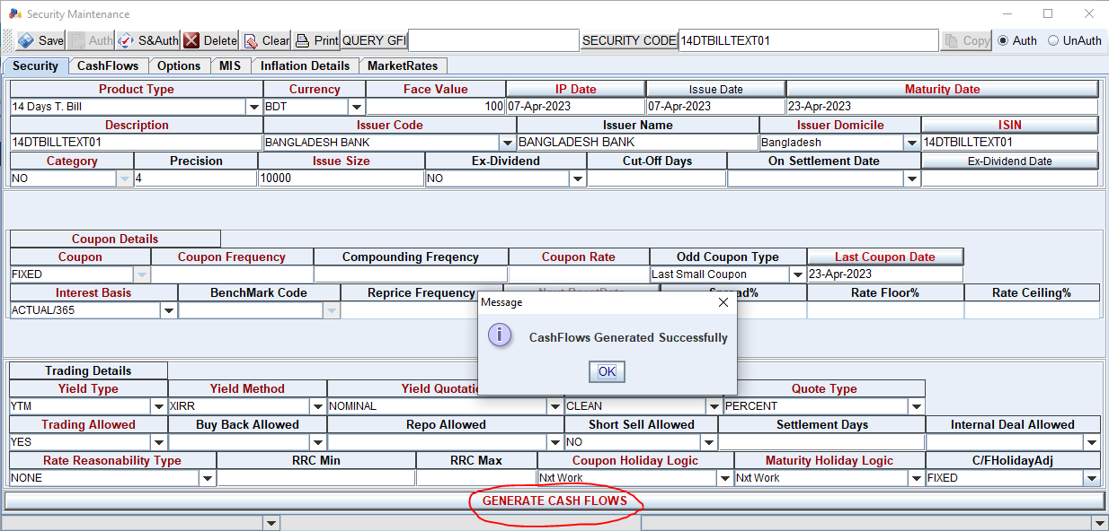

Click CashFlows to see to details:

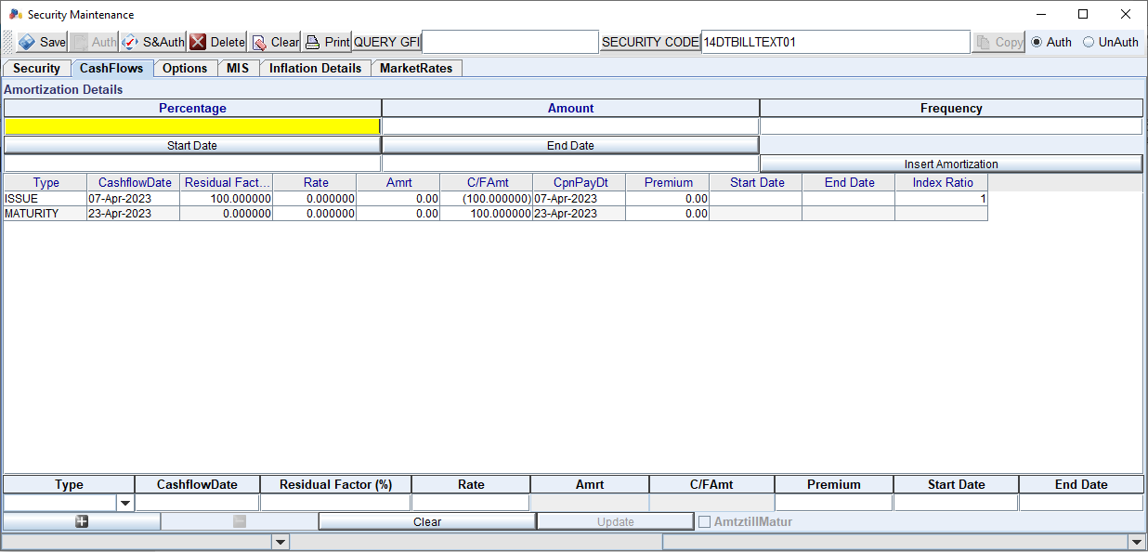

Step 05: Click Save & Auth -> Yes-> create Security

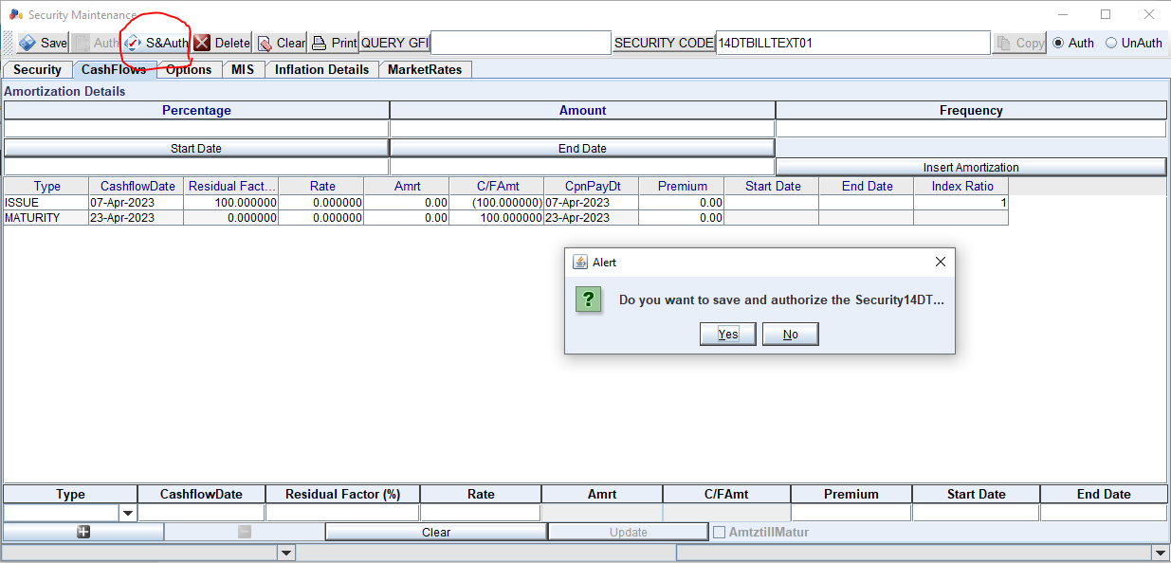

Table of Impact:

* TB_FIS_SECURITY
* TB_FIS_SECU_CASHFLOWS
* TB_FIS_DEAL
* TB_FIS_REPO_DEAL
* TB_FIS_SETTLEMENT
* TB_FIS_DEAL_ALLOC
* TB_FIS_DEAL_LEG
* TB_FIS_DEAL_CASHFLOW
* TB_FIS_CASHFLOW_TXN
* TB_TAX
* TB_ACCENTRIES

Deal Capture: Outright

Step 01: fill up this form input security code (can search by description) then-> input price->input amount (how much buy or sell)-> then double click quantity auto data retrieve. At last click save and release.

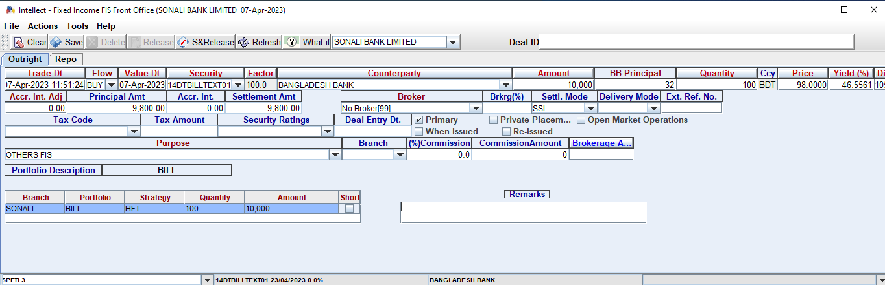

BB Principal: over write the interested amount if any mistake

Amount: Must be within Security issue size

Portfolio Description:

Portfolio: Bill

Strategy: HFT(Help for Trade, any time can be trading ), HFM(Help for maturity, trade after maturity )

Step 02: click Save & Release

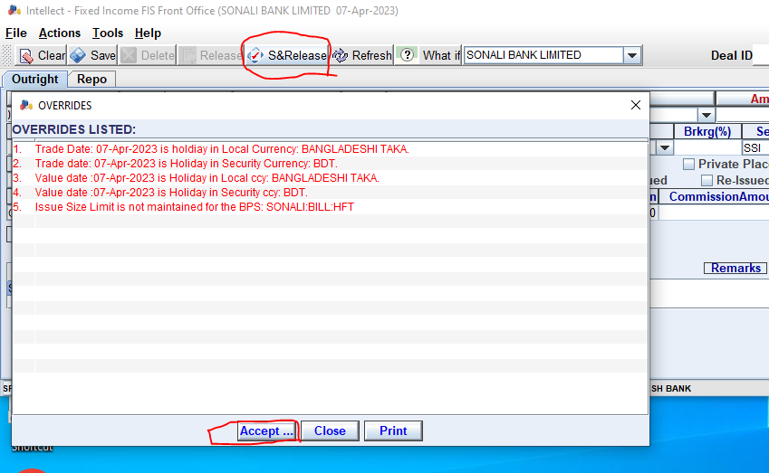

Step 03: Go to back office for deal Authorization save.

click Deal Enrichment-> double click the deal number then auto retrieve data.

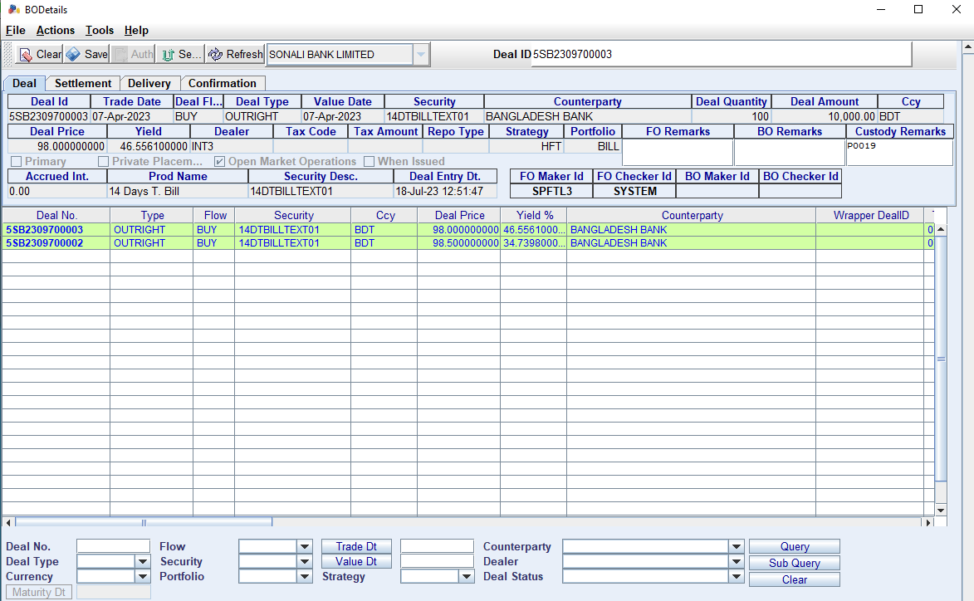

Step 04: Click Settlement

Status -> Settled

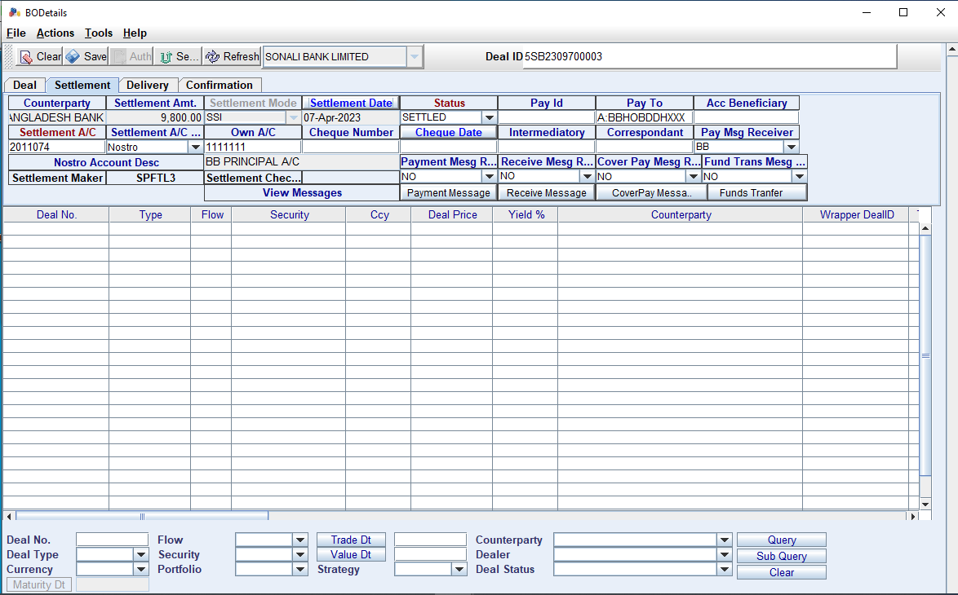

Step 05: Click Delivery

Delivery Mode: RAP

Status: Delivered

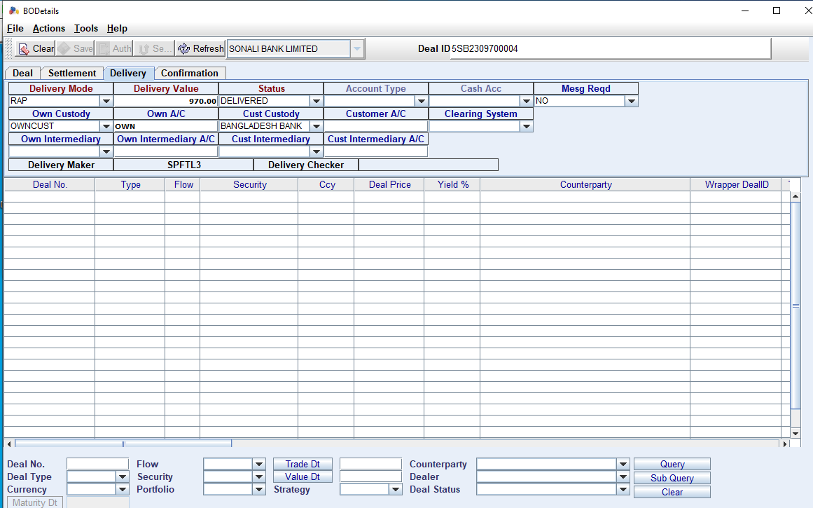

Step 05: Click save not auth FOR SAME USER

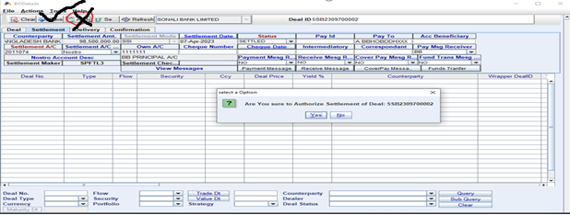

Step 06: Authorization by another user same way step03-05

AT LAST CLICK AUTH

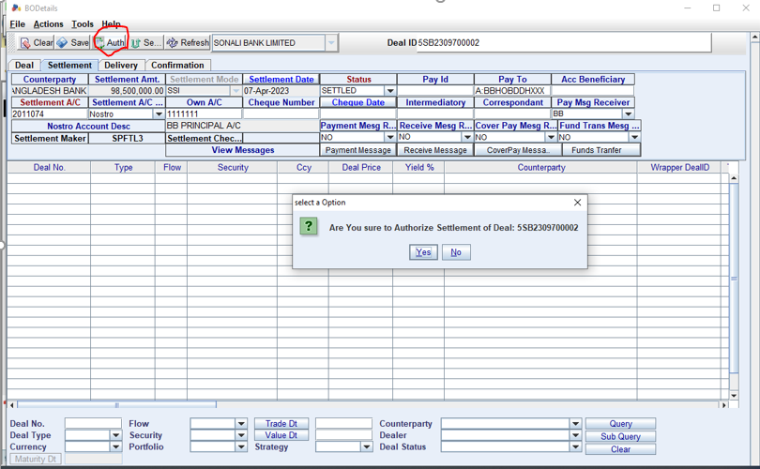

**Security Maintenance: For BOND**

